GSM/GPRS/GPS Vehicle Tracker
Helmer LK 506

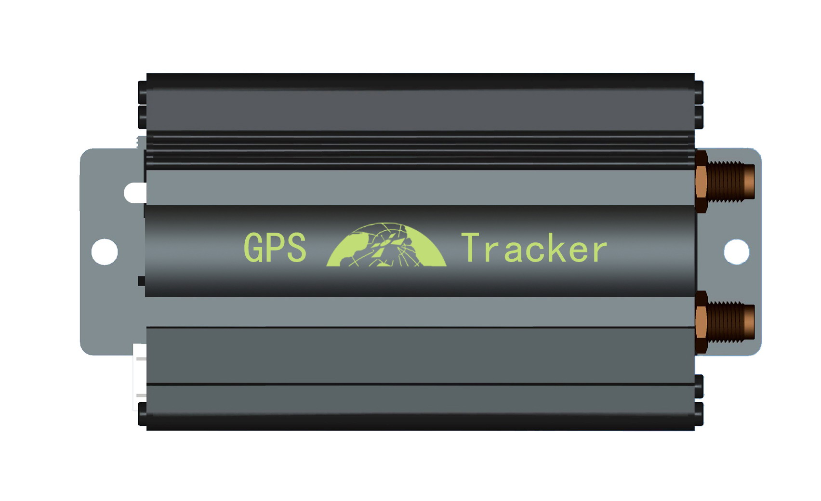

Preface

Thank you for purchasing the tracker. This manual shows how to operate the device
smoothly and correctly. Make sure to read this manual carefully before using this
product. Please note that specification and information are subject to changes without
prior notice in this manual. Any change will be integrated in the latest release. The
manufacturer assumes no responsibility for any errors or omissions in this document.

Contents

1. Function Introduction 3
2. Applications 4
3. Hardware Description 4
4. Accessories 5
5. Specifications 6
6. Operating Instructions 6
6.1 Terminal Installation 6
6.2 SIM CARD Installations 7
6.3 Turn on the Tracker Device 8
6.4 GSM/GPS LED Indicator 8
6.5 Initialization 8
6.6 Change Password 8
6.7 Authorization 9
6.8 Single Locating 9
6.9 Auto track continuously 10
6.9.1 Track with limited times upon time interval 10
6.9.2 Track with unlimited times upon time interval 10
6.9.3 Smart track upon time and distance interval 10
6.10 Turning points update automatically 10
6.11 GPS drift suppression 11
6.12 Exact street address 11
6.13 Location based service (LBS) / Cell-ID Locating 11
6.14 Monitor 11
6.15 Data logging 12
6.16 Data Load 12
6.17 Forward the third parties’ message 12
6.18 SIM card Balance Inquiry 13
6.19 ACC working alarm 13
6.20 Cut off the Oil and Power System 13
6.21 Calibration of fuel sensor 14
6.22 Function of Remote Controller (Option, for model B ONLY) 14
6.23 Arm 15
6.24 Disarm 15
6.25 Silent Mode 15
6.26 Decide how many times of alarm message 16
6.27 Alarms 16
6.27.1 Low battery alarm 16
6.27.2 Power off alarm 16
6.27.3 GPS blind Spot alert 16
6.27.4 SOS 16
6.27.5 Geo-fence 17
6.27.6 Multi-area management 17
6.27.7 Movement alarm 18
6.27.8 Over speed alarm 18
6.27.9 Fuel alarm 18
6.28 Alarms under Arm State 18
6.28.1 Door open alarm 18
6.28.2 ACC Alarm 18
6.28.3 External Shock Sensor alarm(Optional) 19
6.28.4 Built in Acceleration Sensor Alarm 19
6.28.5 Built in Shock sensor sensitivity configuration 19
6.28.6 Alarm without GSM network service 19
6.29 Sleep Mode 19
6.30 Check the Vehicle State 20
6.31 Check IMEI 21
6.32 Terminal (local) Time Setting 21
6.33 Reset Hardware 21
6.34 Configure parameters by USB 21
6.35 GPRS Setting 21
6.36 Less GPRS traffic 22
6.37 Activate "Fuel" value in GPRS data 23
6.38 Instructions for web platform and mobile APP 23
7. Cautions 29
8. Faults & the Solutions 29

- Function Introduction
  - This tracker is a new product based on the GSM / GPRS network and GPS satellite positioning system, which set multiple functions of security, positioning, monitoring surveillance, emergency alarms and tracking in its entirety. It can track and monitor remote target by SMS or internet.
  - Features

- Support both GPS & LBS (Location based service).
- Support SMS/GPRS/Internet Network data transmission
- Support GPRS on-line and GPRS re-connected automatically if GPRS drops
- Support SMS / GPRS dual-mode switching
- Support configuration by remote terminal.
- Support for point-to-point, point to group, group-to-group monitoring.
- Set multiple functions of security, positioning, monitoring surveillance, emergency alarms and tracking in its entirety.
- Applications
Used widely for vehicle and other moving objects tracking.
- Hardware Description
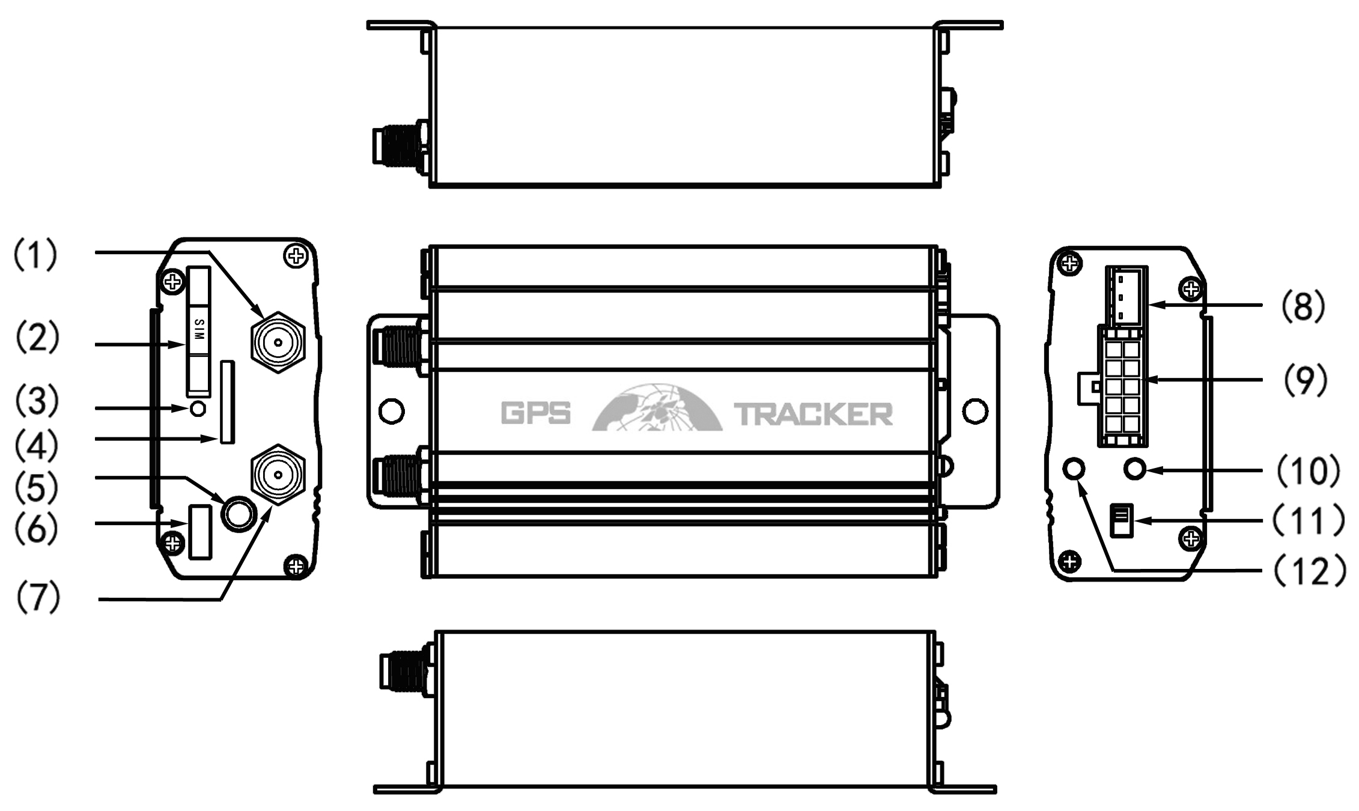
（1）GSM Antenna connector （8）Shock sensor port
（2）SIM card slot （9）Harness Port
（3）SIM card slot Pop-up switch （10）GSM/GPS LED
（4）MicroSD slot （11）Backup battery switch
（5）Microphone jack （12）Remote controller antenna(Optional for Model B only)
（6）Micro USB
（7）GPS Antenna connector
- Accessories

No. | photoes | NAME | note
1 | 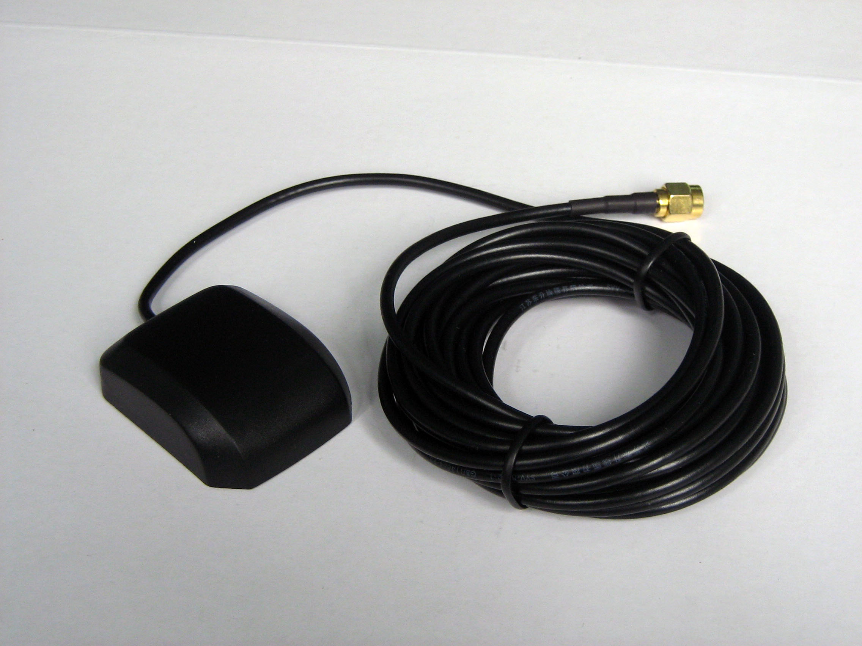 | GPS Antenna | 2 meters
2 | 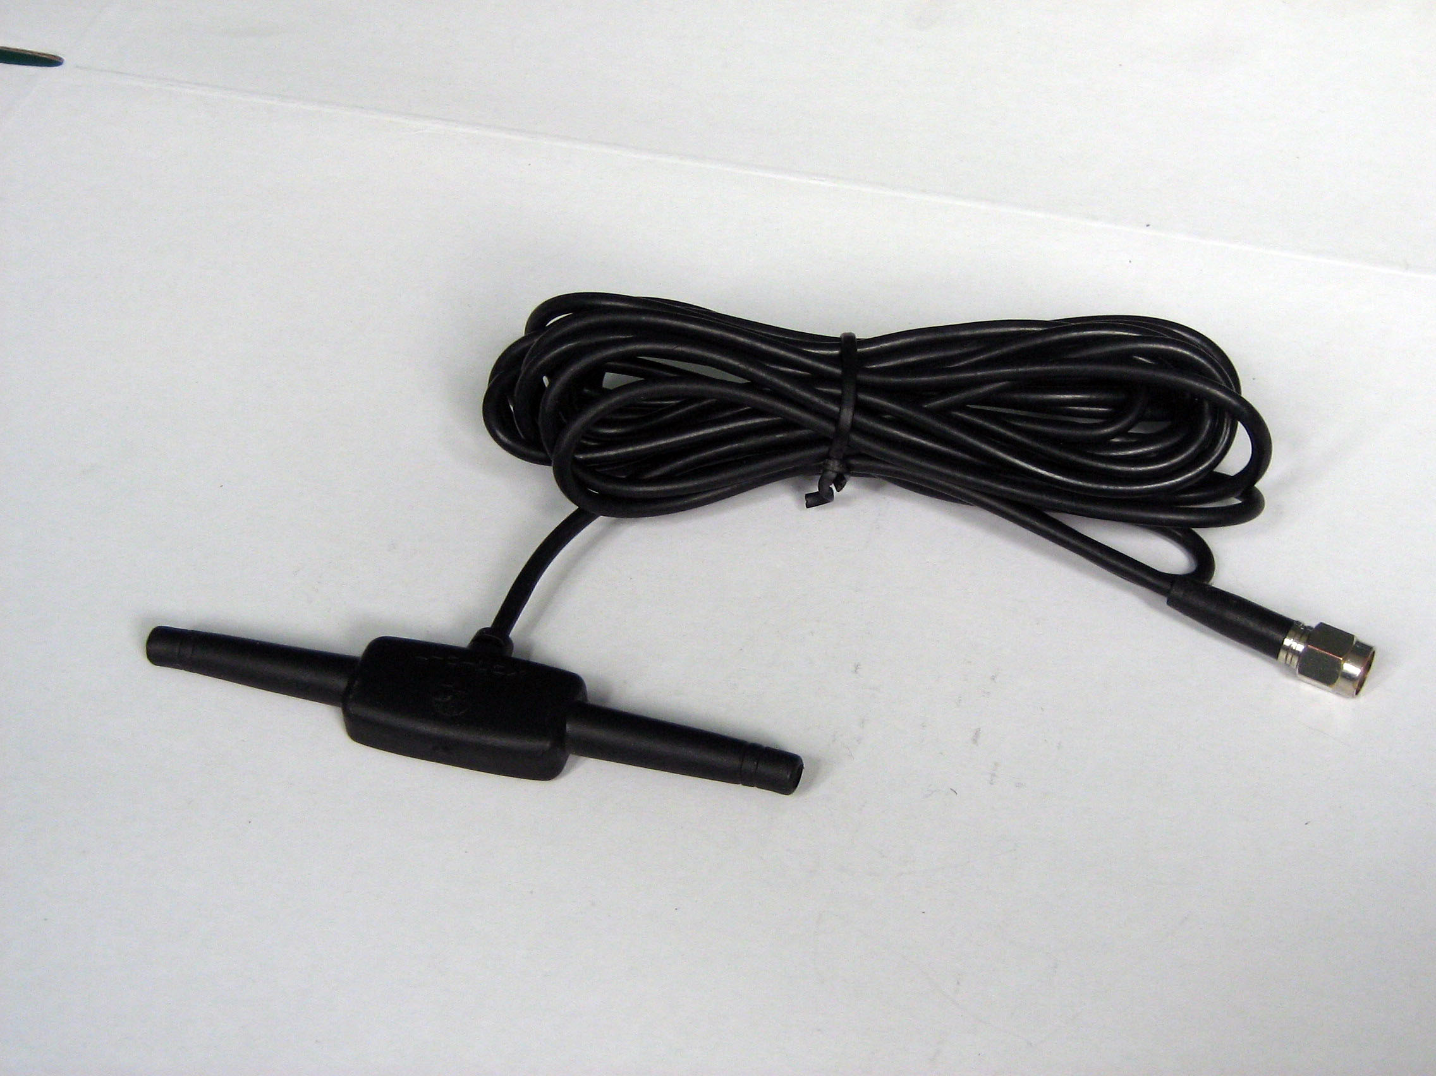 | GSM Antenna | 2 meters
3 | 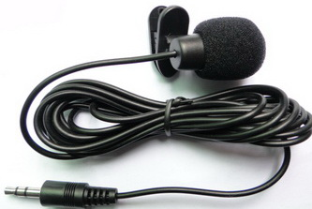 | Microphone | 1.5 meters
4 | 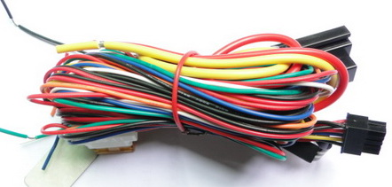 | Harness | 10PIN
5 | 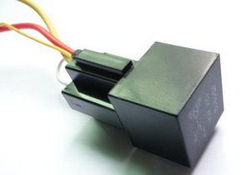 | Relay | 12V/40A to 24V/40A  according to vehicles
6 | 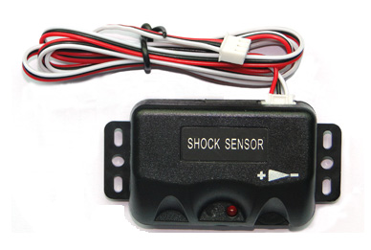 | Shock sensor | Option for both model A and B
7 | 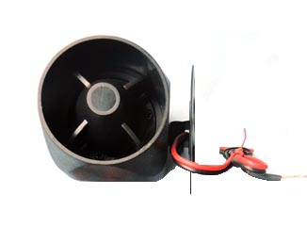 | Siren | Option for both model A and B
8 | 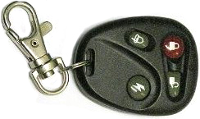 | Remote controller | Option for model B ONLY
9 | 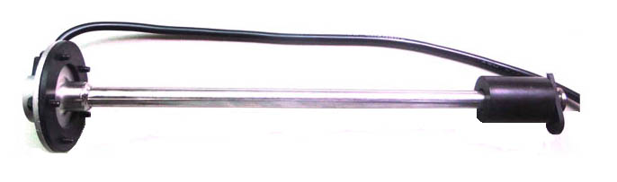 | Fuel Sensor | Option for both model A and B

- Specifications
Content | specifications
DIM. | 83*54*26mm
Weight | 120g
Network | GSM/GPRS
Band | 850/900/1800/1900Mhz
GPS Sensitivity | -159dBm
GPS Accuracy | 5m
GPS Start time | Cold status 45s  Warm status 35s  Hot status 1s
Voltage | 12 V -24V
Backup battery | Chargeable 3.7V350mAh Polymer Li-Battery
Storage Temp. | -40°C to +85°C
Operation Temp. | -20°C to +65°C
Humidity | 5%--95% non-condensing

- Operating Instructions

Terminal Installation
- Please ask the qualified engineers to install it.
- Do not install it in an environment which is over GSM performance index, and please pay attention to fix the antennas in an appropriate position with good signals.
- Pay attention to make installation location preventing water and dust.
- Find the 10 PIN harness and insert it into the corresponding holes of the products, and connect the wires with the original car circuit showing below:

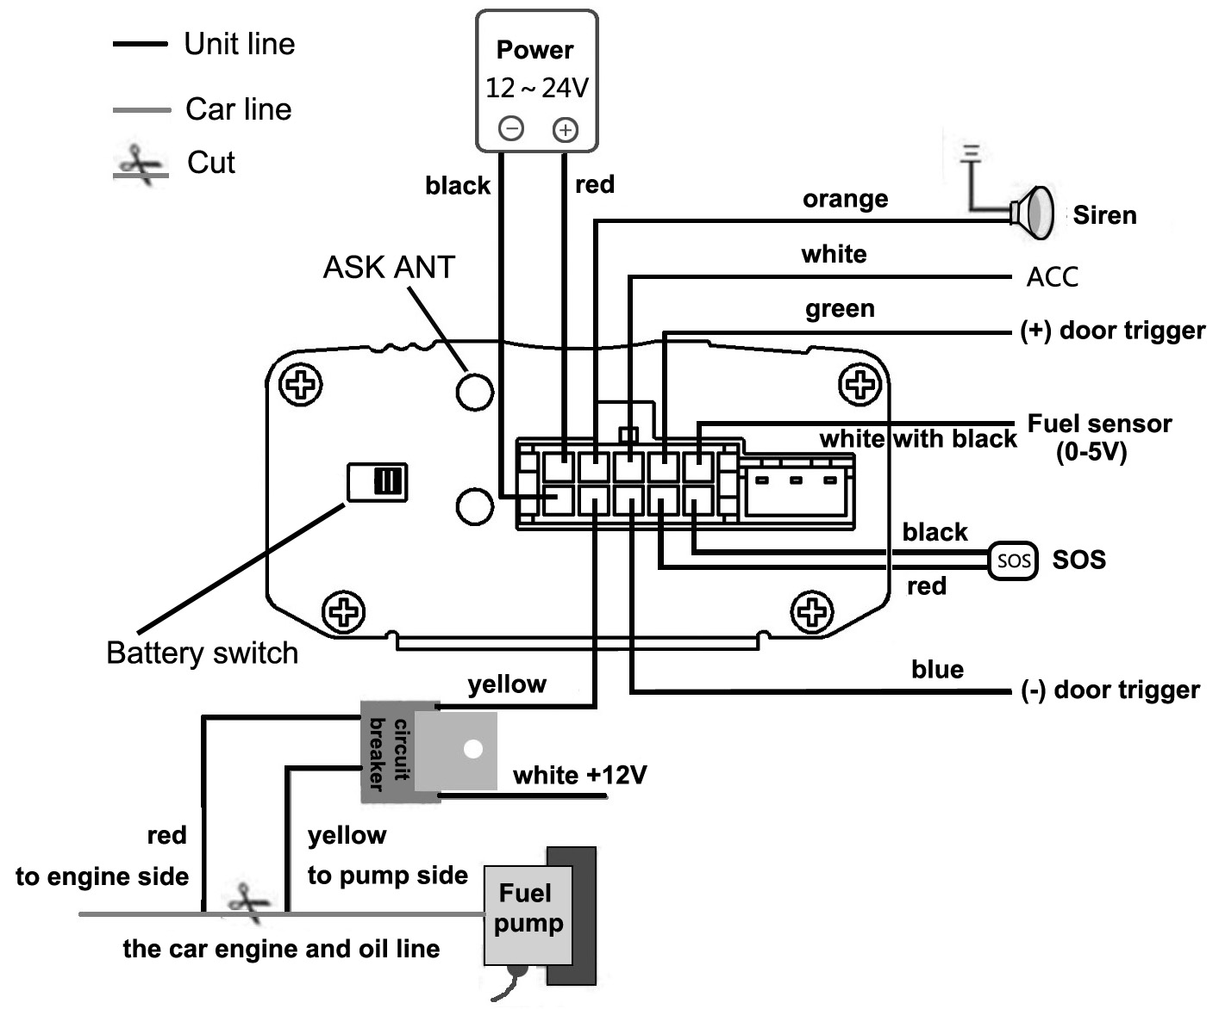
Wiring diagram
Note: The orange wire can be connected to the original car horn; it can also be connected to the siren you buy with the tracker. (Siren is Option)
- Knowing about the type of the door trigger is positive or negative trigger. Please connect the green wire to the door control circuit if it is positive, and connect blue wire if it is negative.
- Please put SOS button at the place driver can touch.
- Insert the shock sensor plug into the sensor jack. (Shock sensor is Option)
- Insert the external monitor Microphone into the monitor jack.
- Connect the GPS and GSM antenna to the right connector, and find an appropriate place to fix the antennas to make sure it receives signals well.

SIM CARD Installations
    - Use a tweezers or a sharp thing to touch the SIM CARD popup switch, the SIM CARD slot will pop up, take out the SIM card slot and put SIM card in it. And then put the SIM card slot back to its original position after confirm the SIM card in the right place.
    - Please make sure the SIM card is for GSM network and able to execute the function of incoming calls display, no calls can be diverted and the PIN code is locked. The SMS format must be TXT format, and can’t recognize the PDU format.

Turn on the Tracker Device
Connect the positive and negative wire, red and black ones, with 12V or 24V car power system, wait for 1 minute after connecting power to wait tracker works normal, and then turn on the backup battery switch.

GSM/GPS LED Indicator
LED Indicator Type | Behavior | Meaning
Red LED | ON | No GSM signal
Red LED | Flash quickly, 1 time  per second | GSM mode with good reception
Red LED | Flash slowly, 1 time  per 3 seconds | GPRS mode
Green LED | ON | Fix to satellites
Green LED | OFF | Lost fix to satellites

Initialization
Send SMS “begin+password” to the unit, it will reply “begin ok” and initialize all the settings to default factory settings.（default password: 123456）
For example: send SMS “begin123456”, it will reply “begin ok”. (No quotation marks“” when sending all the SMS)

Change Password
    - Send SMS “ password+old password+space+new password” to the unit to change the password.
For example: send SMS “password123456 888888” to the unit. If succeeded, “password ok” will reply to your cell phone from the device tracker.

    - Be sure to keep the new password in mind, you have to upload the software to restore the original setting in case of losing the new password.
    - Attention: Make sure the new password is in 6 digits Arabic numbers, or else the tracker cannot recognize the password.
    - When reading this user manual, you will notice that we have used "+" and "space" between some words;"+" between two words means they should be written together as one word and "space" between two words means you should leave one character space between two words.

Authorization
    - You must setup the authorized phone number before using SOS, geo-fence alarm, etc. Up to 5 numbers can be authorized.
    - Call the tracker for 10 times continuously and get its position, then it will save the cell phone number as the authorized number automatically. and reply “add master ok”.
    - Authorization: Send SMS “admin+password+space+cell phone number” to set up an authorized number, the other authorized numbers should be set by the first authorized number, if the number is successfully authorized, the unit will reply “ admin OK” by SMS.
    - Delete authorization: Send SMS “noadmin+password+space+authorized number” to delete the authorized number.
    - If you want to track the target when it enters into another country, you must add the country code before the cell phone number. You should authorize your number in international format as follows: “admin123456 008613322221111” to tracker to set 13322221111 as an authorized number.

Single Locating
    - If there aren’t any authorized number set-up, it will reply all calls with a location report; if there are authorized numbers set-up, then it will not respond when an unauthorized number calls it.
    - If you call it from authorized phone number, it will hang up and report a real-time location as below:

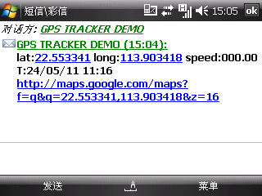
    - When lost fix to satellites, it will track by LBS / CELL-ID. And the SMS will include two positions:
- GPS coordinates of the last known position.
- LAC code. Open web platform and find “manual track”, put code received from tracker in LAC and Cell-ID fields to locate by LBS technology.

Auto track continuously

Track with limited times upon time interval
Send SMS command “fix030s005n +password” to the tracker device, it will report the latitude & longitude at intervals of 30 seconds for 5 times. (s:second, m:minute, h:hour). This command set must be in 3 digits Arabic numbers and the maximum value is 255.
e.g. fix030s005n123456

Track with unlimited times upon time interval
Send SMS “fix030s030m***n+password” to the tracker. Tracker will report a real-time location every 30 seconds when ACC is ON, and report every 30 minutes when ACC is OFF.
Note: The interval must not less than 10s.

Smart track upon time and distance interval
      - Please set "track with unlimited times upon time interval" before this function, and send "distance+password+space+distance", tracker will reply "Distance ok", and then tracker will locate upon both the pre-set time and distance.
e.g. Send "distance123456 0050", it means distance is 50 meters; the number must be 4 digits Arabic numbers.
      - Set this function on web platform: Set time interval first and then distance interval, tracker will locate upon the time and distance.
      - Cancel: Send SMS “nofix+password” to the tracker device to cancel the “auto track”. e.g. nofix123456

Turning points update automatically
    - The tracker will update the positions automatically to web platform once the vehicle changing driving direction over pre set angle value to form a smooth trajectory consistent with the actual road, this function is only effective in GPRS mode.
    - Send "angle+password+space+angle" to tracker, it will reply" angle ok". e.g. angle123456 040
    - The angle must be 3 digits Arabic numbers, default angle value is 30 degree.

GPS drift suppression
    - This function is deactivated by default, to activate this function, send SMS "suppress+password" to tracker, it will reply" suppress drift ok". The GPS data stop updating if vehicle is not driving (ACC is OFF) and latitude and longitude always keep same, and GPS data updates automatically when vehicle is moving.
    - Cancel: send "nosuppress+password" to tracker, it will reply" nosuppress ok ".

Exact street address
- You must set up the APN of your local GSM network for the SIM card in tracker first before using this function, if there is user name and password for GPRS login, Please refer to 6.35.1 & 6.35.2 section of this manual to configure the APN, user name and password for GPRS login.
- After configure the APN, send "address+password" to device, it will reply SMS including real street/address name. For example: No.113, Guankou 2nd Rd, Nantou, Nanshan district, Shenzhen, Guangdong, china.

Location based service (LBS) / Cell-ID Locating
If the tracker cannot establish a solid GPS Fix, it will calculate its location using Cell-ID GSM locating, Location reports will include the GPS coordinates of the last known positions as well as a LAC code, Entering the LAC code to the “Manual Track” menu of web tracking platform www.gpstrackerxy.com will enable you to see the tracker’s current location. You can also send command “address+password” to the tracker to request exact address, track will automatically switch to tracking by LBS in GPRS mode. Accuracy of LBS depends on the distance to the nearest GSM Network Cell Tower or Base Station.
Note: This feature can be used normally in most areas according to the signal of GSM network. It may not be available in some areas.

Monitor
- The command to switch between Tracker mode and Monitor mode are “tracker” and “monitor”.The default mode is “tracker” (Tracker mode).
- Send SMS “monitor+password” to the unit, and it will reply “monitor ok!” and switch to “monitor” mode.
- Send SMS “tracker+password” to the unit, and it will reply “tracker ok!” and switch to “tracker” mode.

Data logging
- Auto logging：When the tracker device lost GSM signals or fall offline from GPRS, tracker will log the tracking position and alerts automatically on the basis of the pre-set condition, when GSM signals get back, all the data will be auto-sent to the authorized numbers or web platform (server).
- Logging upon times: Send SMS: “save030s005n+password” to the tracker unit, it will reply “save ok”, and will log the Latitude and longitude locations every 30 seconds for 5 times. (S: second, m: minute; h: hour).
- Multi-logging：Send SMS:”save030s***n+password” to tracker device, it will reply “save ok”.
- Cancel logging: Send SMS “nosave+password”, e.g. nosave123456
- Logging Clearance: send SMS: “clear+password” to tracker device, it will reply “clear ok”.
- Logging Volume: It depends on the capacity of the SD card inserted in the tracker device.
- The logged data in SD card can be copied to computers through card reader, and then the data route can be checked by importing data in the menu “Data Import” of web platform www.gpstrackerxy.com

Data Load
The positions during the time of signal lost will be sent to server automatically when signals recover.

Forward the third parties’ message
- Send SMS "forward+password+space+third parties phone number" from authorized phone number, tracker will reply"forward ok", and supports 1 third parties phone numbers at most.
For example, set the phone number of the service provider of the SIM card in the tracker, when charge remind message coming in, tracker will forward it to authorized phone number.
- Cancel: Send SMS command "noforward+password".

SIM card Balance Inquiry
- Send SMS command "balance+password+space+carrier’s phone number+space+code" to tracker, it will forward the code to carrier’s phone number and return the balance message received from carrier’s phone number.
- How it works: After accept balance command, tracker will remember the “mobile phone number”, carrier’s phone number and the code;
- And then send the code to carrier’s phone number, and forward the message from carrier to mobile phone number.
Take china mobile for example, mobile users can send “ye” to china mobile number 10086, and 10086 will send user’s balance message to tracker, and then tracker forward the balance message to mobile phone number , following is an illustration how this function works.
Send balance back
Mobile
balance123456 10086 ye
Tracker
Received and execute
Send ye out to 10086
10086(China mobile)

Received ye from number in the tracker and process
Received Balance message
Forward balance message to mobile phone

ACC working alarm
- This function is deactivated by default. To active this functions, send "ACC+password" to tracker, it will reply "ACC ok". And tracker will send "ACC on+latitude & longitude" to authorized numbers when detect ignition on, that means the vehicle has been started; and tracker will send “ACC off+latitude & longitude" to authorized numbers when ignition off and ACC is off, that means vehicles has been stopped.
- Send "noACC+password" to deactivate this function, tracker will reply "noACC ok".
- This configuration can only activate and deactivate the alarm to authorized numbers; it will send to web platform automatically in GPRS mode and can't be deactivated.

Cut off the Oil and Power System
- Send command “stop+password” to tracker, tracker will execute it and reply “Stop engine Succeed”. And it will remain immobile state until next command to resume.
- Stop mode
Execute immediately: Send command “quickstop+password” to tracker, it will reply “quickstop OK”. Then tracker will stop the car immediately after “stop” command.
Execute depends on speed(Default mode): Send command “noquickstop+password” to tracker, It will reply “noquickstop OK”, Then the tracker won’t stop the car immediately after “stop” command, instead, it will reply “it will be executed after speed less than 20KM/H”, and stop the car when the speed is less than 20KM/H.
- Resume the Oil and Power System
Send “resume+password" to tracker, it will reply "Resume engine succeed", it means the oil supply is resumed .

Calibration of fuel sensor
- Due to the different height of fuel tank and fuel level sensor specifications, tracker need to set an appropriate zero value and full range value to detect the precise fuel percentage.
- Zero calibration: Send “ oilzero+password “ to tracker when the fuel tank is empty , tracker will adjust to zero and reply “ oilzero ok!” . The fuel value is 0%.
- Full calibration: Send “oilfull+password “ to tracker when the fuel tank is full , then tracker will adjust to full range and reply “ oilfull ok! “ . The fuel value is 100%.

Function of Remote Controller (Option, for model B ONLY)
Button | Function | Descriptions
 | ARM | Press for 0.5 second, the siren will beep one time.
 | DISARM | Press for 0.5 second, the siren will beep two times.
 | ARM & Silent mode | Press for 0.5 second when it is in disarm state, the siren will beep one times. No voice from siren when alarm triggered and quit from silent mode automatically when disarm.
 | SOS | Press for 3 seconds, Tracker will send SOS alert to authorized phone numbers without voice.
 | Deterrence/car search | Press for 0.5 second when it is in arm state, siren will beep 10 seconds, press disarm button to quit.

Arm
- Set up arm by SMS
Send SMS command “arm+password” to the tracker device in the vehicle. It will reply “Tracker is activated” in both armed and disarmed state, and the SMS command will make the tracker device enter into armed state if the unit currently disarmed.
User must stop the engine, (that is ACC is lower voltage).Sending SMS “arm+password” when close the door and left. You will set up arm status fail if the engine is turned on (the ACC is high voltage), it will reply “set up fail! pls turn off ACC”
- Set up arm by remote controller (Option, for model B ONLY)
Press button on the remote controller for 0.5 seconds, the car enters into armed state and the siren will beep one time, no SMS reply.

Disarm
- Disarm by SMS
Send SMS command "disarm + password" to the tracker device in the vehicle, It will reply “Tracker is deactivated” in both armed and disarmed state, and the SMS command will make the tracker device enter into disarmed state if the unit currently armed.
It won’t alarm if the door is open and sensor is vibrated and the engine is started when arm function is deactivated .
- Disarm by remote controller (Option, for model B ONLY)
Press button on the remote controller, the car enters into disarm state, and the siren will beep two times, no SMS sent.

Silent Mode
- Set up silent mode by SMS
Send SMS “silent+password” to tracker device, it will reply “silent ok!”. It means tracker device enters into silent mode, siren won’t be sound after alarm is triggered, but tracker will send alarm SMS to authorized number.
Send disarm command “disarm+password” to quit silent mode .
- Set up silent mode by remote controller (Option, for model B ONLY)
Press in disarm state for 0.5 second, the siren will beep one
time, Tracker device enters into silent mode, siren won’t be sound after alarm is triggered, but tracker will send alarm SMS to authorized numbers.
Press to quit silent mode.

Decide how many times of alarm message
You can decide how many times of the alarm message to be sent, For those alarm message sent in cycle, you can limit the times the alarm message to be sent. send SMS “ xtime+password+005 “ to tracker, alarm message will be sent 5 times once alarms are triggered .
Alarm SMS will be sent 5 times by default.

Alarms

Low battery alarm
- Send SMS “lowbattery+password+space+on”, it will send SMS “low battery+latitude/longitude” to authorized numbers 2 times in total in 15 minutes interval when voltage of battery is going to be about 3.55V.
- This function activates by default, send SMS “lowbattery+password+space+off” to deactivate.

Power off alarm
- Send “ extpower+password+space+on” to activate, it will send SMS “power alarm+latitude/longtitude” to authorized numbers every 3 minutes when external power is cut off.
- This function activates by default.
Cancel: Send SMS “ extpower+password+space+off” to deactivate it.

GPS blind Spot alert
- This function deactivates by default, send SMS “gpssignal+password+space+on”, it will send alert SMS “no gps+last valid latitude/longitude before lost signal”
- Send SMS “gpssignal+password+space+off” to deactivate.

SOS
Long Press the SOS button for 3 seconds（For model B, press button on remote controller for 3 seconds）, the tracker device will send SMS “help me!+lat./long.” to all the authorized numbers at interval of 3 minutes. It will stop sending such a SMS when any authorized number reply SMS “help me!” to the tracker.

Geo-fence
- Set up a geo-fence for the tracker device to restrict its movements within a district. The unit will send SMS to the authorized numbers when it goes out of this district.
- Set up: When the unit stays immobile in a place for 3-10 minutes, the user can send
SMS“stockade+password+space+latitude,longitude;latitude,longitude” to unit to set the restricted district. In case of breach, it will send SMS “stockade!+ latitude & longitude” to the authorized numbers.
Remark: The first latitude & longitude is coordinate of the top left corner of the Geo-fence, while the second latitude & longitude is the coordinate of the bottom right corner, it will send alarm SMS at interval of 3 minutes once beyond the restricted district.
- Cancel: Send SMS “nostockade+password” to deactivate this function.

Multi-area management
- Set Area
Send SMS command "area+password+space+latitude,longitude+space+areaname,distanceM" to tracker(distance unit: M for meter, K for kilometer), it will reply "area01 ok".
Example: Send "area123456 22.353648,113.543678 school,800M".
Note: 5 areas at most and the distance between two points can't be less than the total distance in the 2 commands, and different areas can't cover each other.
- Delete areas
Send SMS command:"noarea+password+space+area name", tracker will reply:"noarea ok".
- Rename and set distance
Send SMS command "rename+password+space+old name;new name,distanceM" to tracker, if name is not repeated and area doesn't cover others, it will reply "rename ok!" for successful configuration.
Example: Send"rename123456 area01;school,800M", it means the new area name is "school", and covers area of a radius of 800 meters.
- Activate multi-area management
Send SMS command "area+password+space+on" to tracker, it will reply "Area
on ok!", when tracker enter the pre set area, it will send SMS "area
name+latitude & longitude" to all the authorized phone number, and send same
SMS when goes out of the area.
- Deactivate Multi-area management
Send SMS command "area+password+space+off" to tracker, it will reply"area off ok!"

Movement alarm
- Set up: when the unit stays immobile in a place for 3-10 minutes with GPS signal reception, the user can send SMS“move+password+space+0200” to the tracker (Suppose area of a radius of 200 meters, it supports 4 digits at most. Unit: Meter). It will reply “move OK”. In case of such a movement (the default distance is 200m), it will send SMS “Move+ latitude & longitude” to the authorized numbers at interval of 3 minutes.
- Cancel: Send SMS “nomove+password” to deactivate the movement alarm.

Over speed alarm
- Set up: Send SMS “speed+password+space+080” to the unit (suppose the speed is 80km/h), and it will reply “speed OK!”. When the target moves exceeding 80km/h, the unit will send SMS “speed+080!+ latitude & longitude” to the authorized numbers ,it will only send one SMS in 3 minutes in SMS mode when overspeed ; the siren will beep 1 time when overspeed 1 time.
- Cancel: Send SMS “nospeed+password” to deactivate the overspeed alarm.
Remark: The recommended speed should be not less than 30km/h. For below that rate, it will be effected the accuracy by GPS signals drift etc.

Fuel alarm
- When the fuel consumption exceeds the normal standards during driving, or oil theft/leakage when the vehicle is stopped, the tracker will send "oil: xx% + Geo-info" to the authorized number at interval of 3 minutes. The horn beeps 20S.
- Cancel: Send SMS command “ nooil+password” to tracker.

Alarms under Arm State

Door open alarm
The unit will send SMS “Door alarm+lat/long” to the authorized number at interval of 3 minutes when the door of the car opens in arm status. Siren will be sound for 20 seconds, and repeat sound at interval of 20 seconds minutes if the door is always open. Disarm to stop this alarm

ACC Alarm
The unit will send SMS “ACC alarm+lat/long” to the authorized number at interval of 3 minutes when the engine of the car is turned on, that is the key is rotated to “ACC ON” position to start the car in arm state; Siren will be sound for 20 seconds, and repeat again at interval of 20 seconds if the ACC always keep ON.
Disarm to stop this alarm

External Shock Sensor alarm(Optional)
The unit will send only one alarm SMS “Sensor alarm+lat/long” to the authorized number in 3 minutes when the sensor is triggered in arm status. Within 3 minutes, the alarm siren sound for 5 seconds when the vibration is detected in the first time and second time. The alarm siren sound for 10 seconds when vibration again. If you disarm the tracker, the times will reset.
Disarm to stop this alarm.

Built in Acceleration Sensor Alarm
The tracker is built in three axis acceleration sensor, the tracker can detect it in arm state when the vehicle move, tilt or shock. The alarm way is same as the external shock sensor alarm.
Disarm to stop this alarm.

Built in Shock sensor sensitivity configuration
The sensitivity of the built-in shock sensor has three different level:
First level: Alarm will be triggered after detect slight vibration, send command" sensitivity+password+space+1" .
Second level: Alarm will be triggered after detect 8 times vibration in 2 seconds, send command" sensitivity+password+space+2".
Third level: Alarm will be triggered after detect 25 times vibration in 5 seconds, send command" sensitivity+password+space+3".

Alarm without GSM network service
When the car is in the place without GSM network service, siren will be sound under non-silent mode if alarm is triggered (door, sensor, ACC), but no SMS alarm will send to authorized number.

Sleep Mode
 | SMS Mode | GPRS Mode | Set Less GPRS Traffic in GPRS Mode
No  Sleep | Work | Online | ACC Off. No Calling, SMS and any triggered alarm, GPRS disconnect and switch to SMS mode, sleep. ACC on or Calling, SMS and any triggered alarm can awake it, and GPRS connect
Sleep | ACC off. No Calling,  SMS and any  triggered alarm, go to  sleep, GPS module  shut off, GSM  module work in low  power consumption.  ACC On or Calling,  SMS and any  triggered alarm can  awake it. | Online | ACC Off. No Calling, SMS and any triggered  alarm, GPRS disconnect and switch to SMS  mode, go to sleep. ACC on or Calling, SMS  and any triggered alarm can awake it, and  GPRS connect.

    - This function is deactivated by default, send “sleep+password+space+on”, tracker will reply “sleep on ok”. When vehicle is not driving (ACC is OFF), GSM module fall asleep; GPS module shut off; and tracker works in low power consumption. Calling, SMS command and any triggered alarm can awake it.
    - Cancel: Send “sleep+password+space+off”, tracker will reply “sleep off ok”, tracker won’t sleep, GSM and GPS works all the time.

Check the Vehicle State
Send SMS command “check+password” to the tracker in the vehicle, It will reply SMS as follows:
Power: ON/OFF
Battery: 100%
Oil: 100%
GPRS: ON/OFF
GPS: OK/NO GPS
ACC: OFF/ON
Door: OFF/ON
GSM Signal: 1-32 Note: The higher digit it shows; the better.
APN: cmnet
IP: 104.250.138.146
PORT: 9000

Check IMEI
Send SMS command "imei+password" to the device. E.g: Send SMS command
"imei123456" to the tracker device, it will reply an IMEI number in 15 digits to
your cell phone.

Terminal (local) Time Setting
- Send SMS command “time+space+zone+password+space+time” to the device, If succeed, it will reply “time OK”
- For example: Send SMS “time zone123456 8”, 8 is Chinese time zone, If your country time zone is minus, send SMS “time zone123456 -8”.

Reset Hardware
Send SMS “reset+password” to tracker device to reset the GSM module and
GPS module of the tracker device, it will reply “reset ok”.

Configure parameters by USB
Connect tracker to computer with the optional USB cable, open the memory
of the tracker, find and open the initial configuration file with
notepad, operate according the instructions.
Note: Correct password is needed every time you configure the tracker.

GPRS Setting
User must send SMS via cell phone to set up APN, IP and port before starting
tracking by GPRS.

- Configure APN
APN standards for Access Point Name and differs from country to country. For more information about your local APN, please inquire with your local GPRS network operator.

Send a SMS command to tracker “APN+password + Space + your local APN” via a cell phone and if succeeded, the tracker will reply “APN OK”.
For example: Send SMS command “APN123456 CMNET”. If succeeded, the tracker will reply “APN OK”.
Notes: 123456 refer to password of tracker and CMNET is the
APN of one of china GPRS Network Operator (China mobile).

- GPRS User Name and password Setup
- In most countries, the user name and password involving GPRS login are not compulsorily necessary, therefore, the entry can be skipped. As for those countries require user name and password, please configure as following:
- Send SMS “up+password+space+user+space+password” If succeeded, the tracker will reply “user, password ok!”
- For instance, send SMS “up123456 web webgprs” to the tracker, and if succeeded, tracker will reply “user, password OK”
Note: 123456 is password for the tracker, web is the user name for GPRS login,
webgprs is the password for GPRS login.

- IP and Port Setup
- Send SMS as below via a cell phone: “adminip+password+Space+IP Address+Space+Port Number”. If succeeded, tracker will reply “adminip OK”.
- For example: Send SMS command “adminip123456 202.104.150.75 9000” to the tracker, If succeeded, it will reply “adminip OK”. ( 123456 is default password，202.104.150.75 is IP，9000 is port).

- Switch to GPRS mode
- The default mode is “SMS”, Send SMS “GPRS+password” to the tracker, and it will reply “GPRS ok!” it means the tracker has switched to “GPRS” mode.
- TCP and UDP switch
Command: "gprs+password,0,0" switch to TCP mode, this is the default mode.
Command:"gprs+password,1,1" switch to UDP mode.

- Send SMS “SMS+password” to the tracker, and it will reply “SMS ok!” and restore to “SMS” mode.

Less GPRS traffic
- Tracker will change to less GPRS traffic mode after parking 5 minutes (ACC is OFF), GPRS disconnect and connect again when alarm being triggered or vehicle starts driving.
- Activate this function: Send "less gprs123456 on", tracker will reply "less gprs on ok".
- Deactivate this function: Send "less gprs123456 off", tracker will reply" less gprs off ok".
Note: 123456 is the password of tracker, and replace it with the new if you have changed.

Activate "Fuel" value in GPRS data
The default format of GPRS data doesn't include "Fuel" value, if you need "Fuel"value, please send “protocol+password 18” to tracker, if succeed, it will reply "protocol 18 ok"; send “protocol+password 12” to change back to default mode, if succeed, it will reply "protocol 12 ok".

Instructions for web platform and mobile APP
Users need to regsiter an account on www.gpstrackerxy.com before use web or APP platform, account name and password is the same on web/APP platform

    - register an account

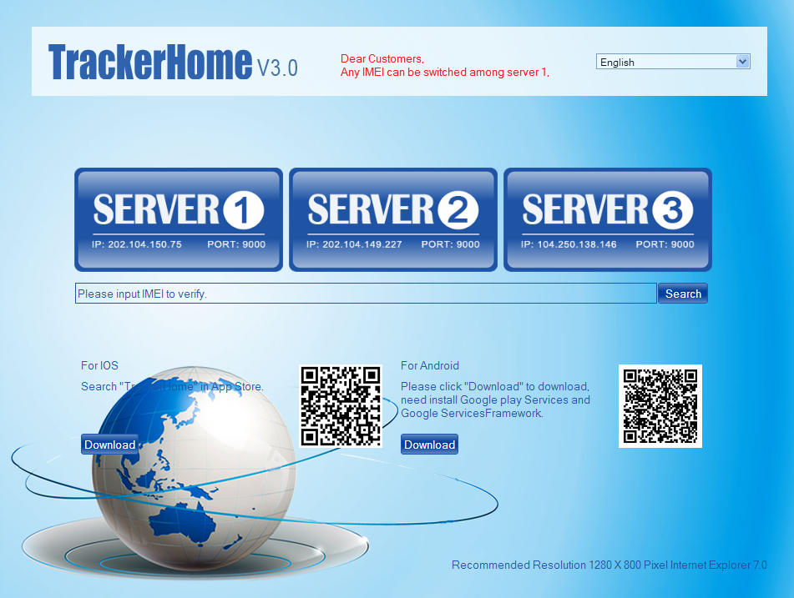
1、choose the right server to login in
2、Validate your IMEI is valid or not
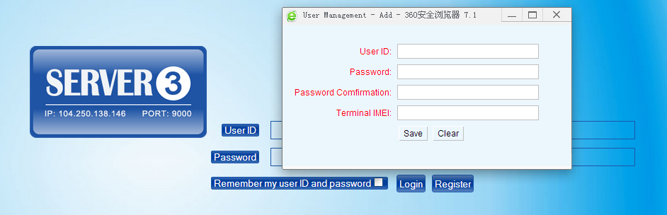
3、Click "register". Pop-up a dialog box, register an account
    - Login

4、Input the newly registered user ID and password, click "login"

    - Add a terminal
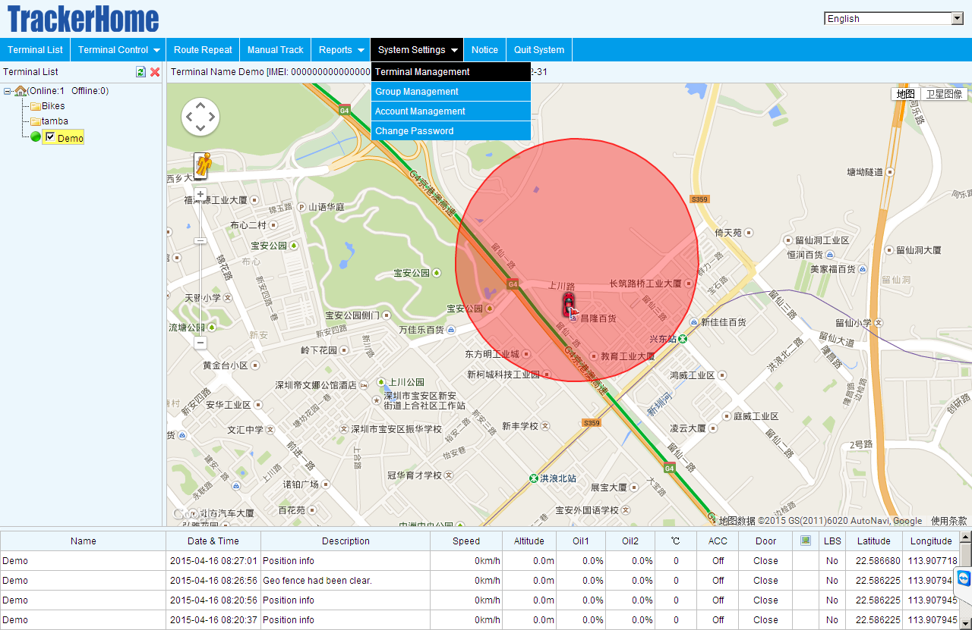
5、add terminal
6、add terminal

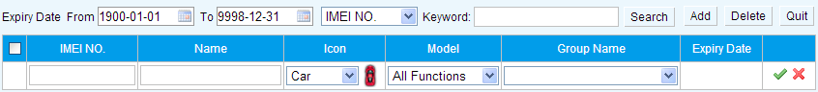
7.enter IMEI
10、save
8. name
9、choose location icon

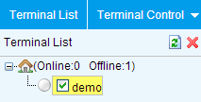
11 .the newly registered device is offline in grey color
    - Configure your tracker to web platform to track it online
step 1：set APN，refer to 6.35.1
Step 2：set GPRS user name and password，refer to 6.35.2
Step 3：set IP and port, please use the corresponding IP and port of the server you choose, refer to 6.35.3
Step 4：switch to GPRS mode，refer to 6.35.4
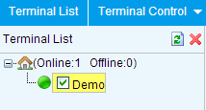
12. After receiving GPRS OK, wait about one minute, tracker will be online in green color, you can operate the tracker,

    - If the tracker is always offline (grey color), make sure the SIM card subscribe the GPRS service,
and have money to surf the Internet, you can use phone to test the sim card can surf the Internet or not
please check the APN, user name, password, IP, port settings are correct, refer to 6.30.

    - IOS &Android mobile APP
- Download and install the mobile APP software
According to your phone type, download and install mobile app below the home page
on web tracking platform

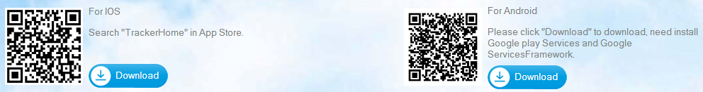

6.38.6.2 Login in and use the mobile APP under GPRS version
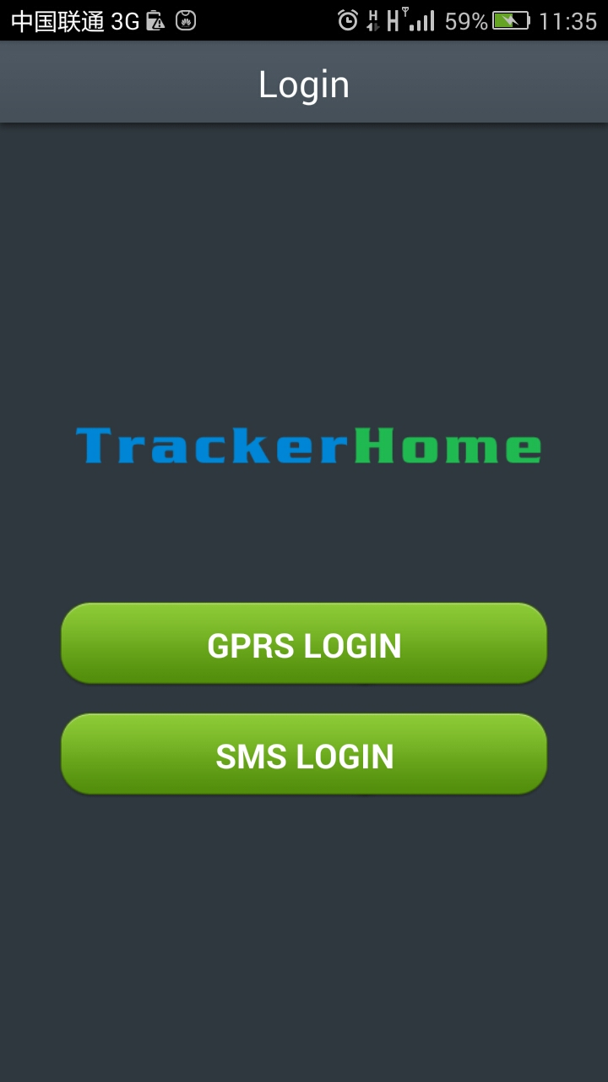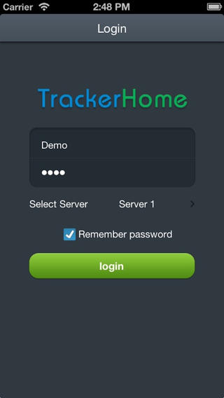
2. Filling the registered user ID and password

3.Choose the right server

4.Click”login”
1. CHOOSE GPRS
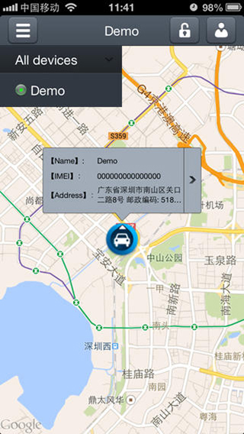
5. Click here to operate the device

6.38.6.3 login in and use the mobile APP under SMS version
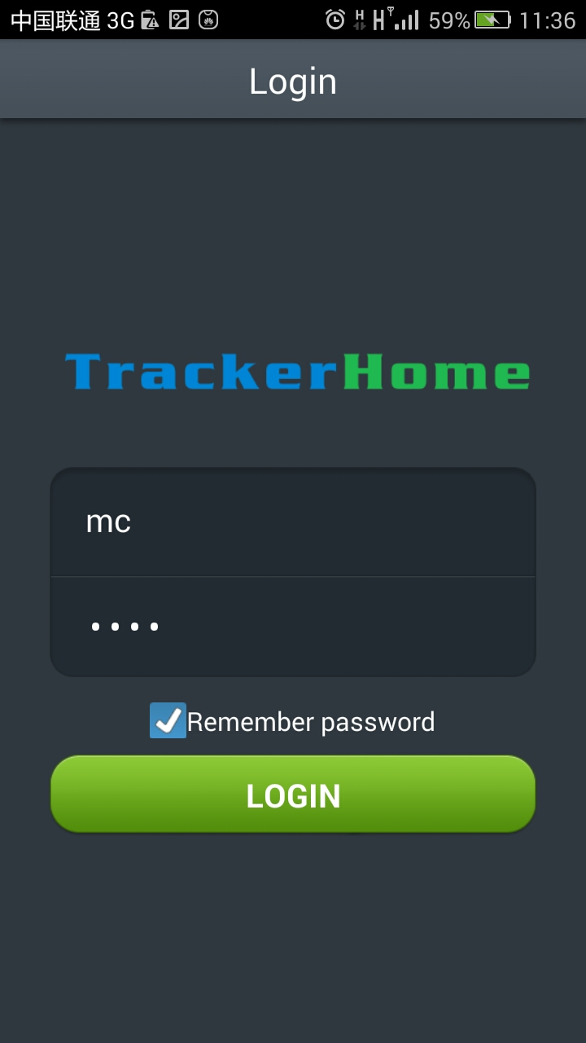
1.Choose SMS LOGIN
3.Click “login”
2.Use”mc” as the initial user ID,password is 8888, change the user name and password after entry

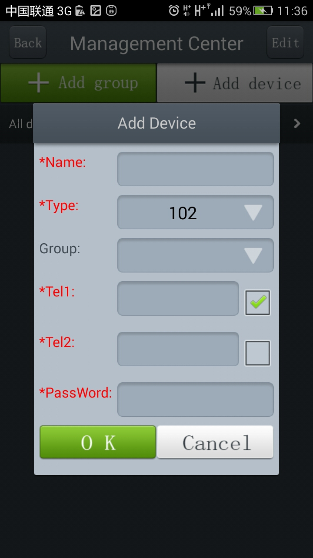
4. Choose “add device”
5. Filling the device name
6. Choose the type
7. Filling the phone number of device
8. Filling the tracker’s password
9. Click “ok”
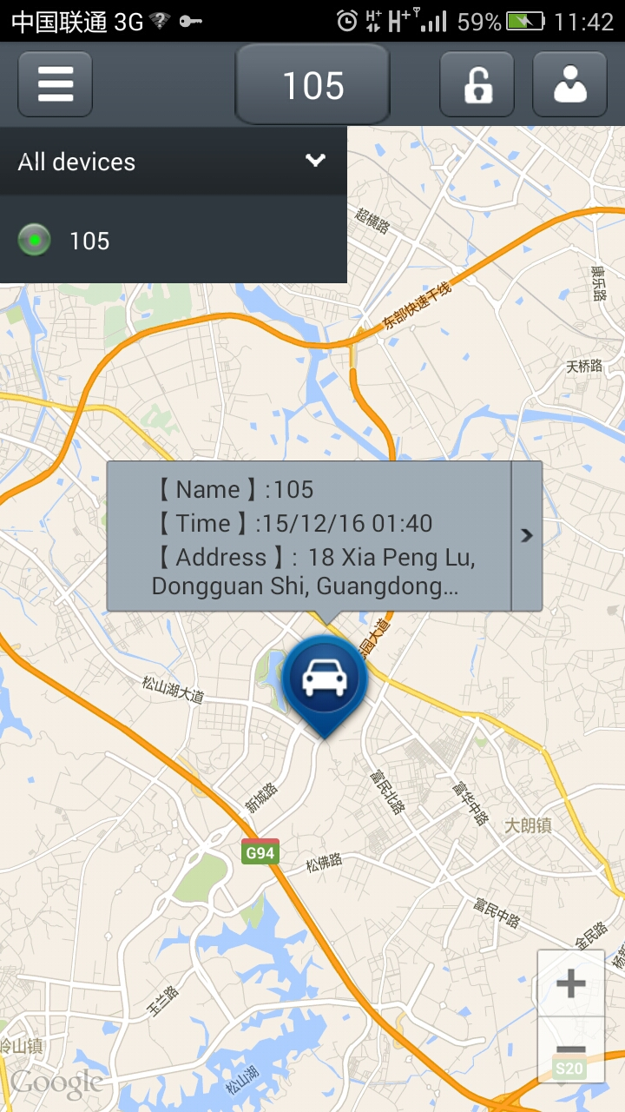
10. Click the icon, and display the list
11. Click here to operate the device

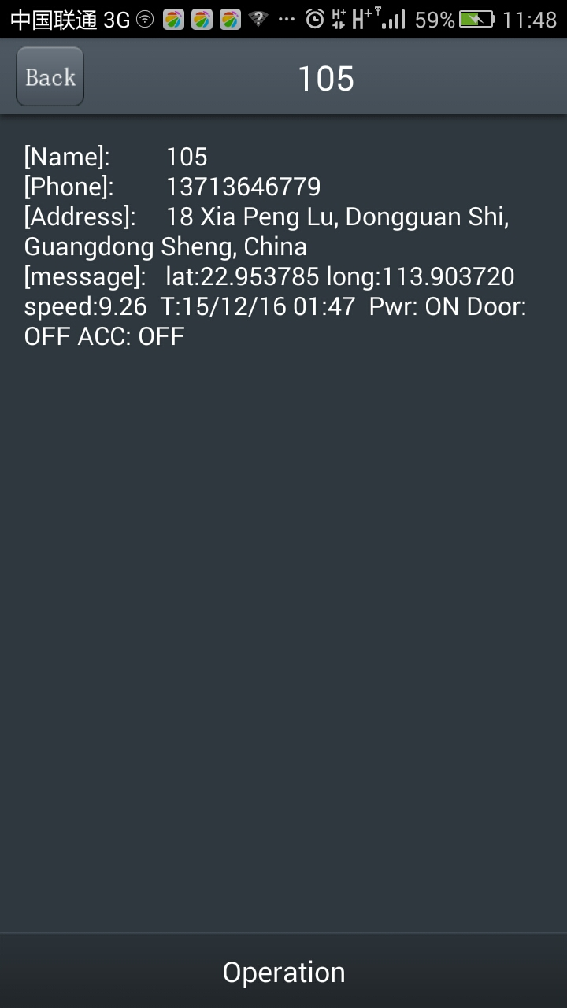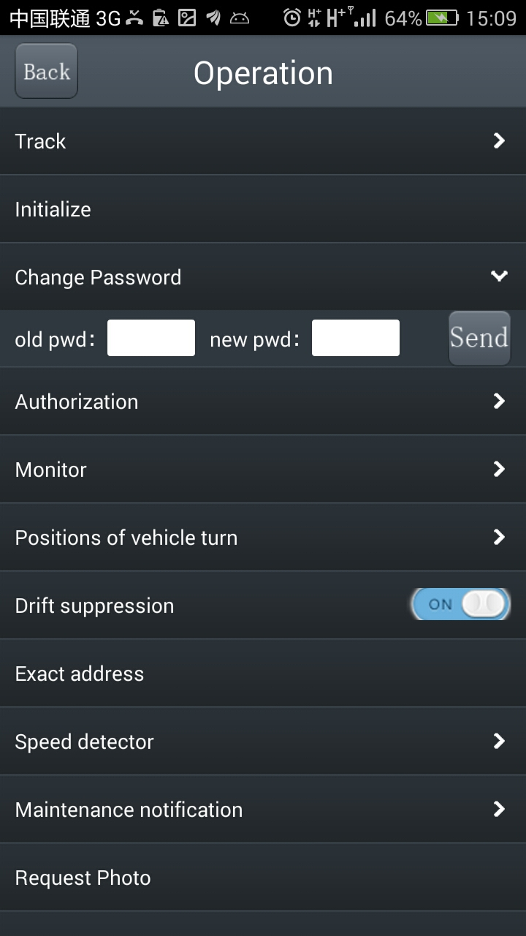
13.Click the buttons to send commands
14.Filling parameters manually and then click “send”
12.Click here to see more menu

Remarks: APP on Android phone can track the address and show alarm by SMS; IOS APP can only send commands due to the confined policy

- Cautions
Please comply with the instructions to extend the unit life:
1. Keep the unit dry. Any liquid, i.e. rain, moisture, may destroy or damage the inside circuitry.
2. Don’t use & store the unit in dusty places.
3. Don’t put the unit in overheated or overcooled places.
4. Handle carefully. Don’t vibrate or shake it violently.
5. Clear the unit with a piece of dry cloth. Don’t clean in chemicals, detergent.
6. Don’t paint the unit, this may cause some foreign materials left in between the parts.
7. Don’t disassemble or refit the unit.
8. Please read the user manual carefully before installation and operation, learn something more about the voltage range. Otherwise, it won’t work properly or destroy the product.

- Faults & the Solutions
Faults | Solution
Fail to turn it on | Please check if built-in battery is charged, and power wires  connected well.
No GSM signal | - Please check if SIM card installed correctly.  - Please check if SIM card is GSM network.  - Don’t turn on the PIN code  - no calls can be diverted  - Please check if voltage of the power is normal
No GPS | Please check if GPS antenna connected well, and recommend GPS  antenna be installed near the window glass, no metal parts can  cover it to make sure better GPS signal reception.
No reply to SMS command | Password wrong or the format is wrong.
No reply to calling  不能收到报警短信 | Authorized / admin phone number is incorrect
No alarm message | Authorized / admin phone number has not setup

